**Exercise**

NB! Read through the below instructions before you start.

Note the following

1. This is a technical as well as visual exercise. Use your own colors and theming to give it some personality.
2. Read carefully and follow the instructions closely.
3. Where specific details are not clear, implement what you infer from the instructions.
4. Don’t minify your code.
5. No extra context or guidance will be provided.

Initial page setup

1. Open Developer Tools in Chrome Browser.
2. Toggle device toolbar and select the Pixel 2 device in portrait orientation.
3. Create a page as wide as the emulated screen and twice as tall as its screen.
4. On it, create a square with sides 30% of the width of your page.
5. Below it, create a rectangle, 60% of the width of the page, and half as tall as it is wide.
6. Below the rectangle, create a circle in the horizontal middle of the page, 40% as wide as the screen.
7. Put your name in the bottom left corner of the screen. Ensure that your name stays in place when you scroll down your page.

Your page should look like this: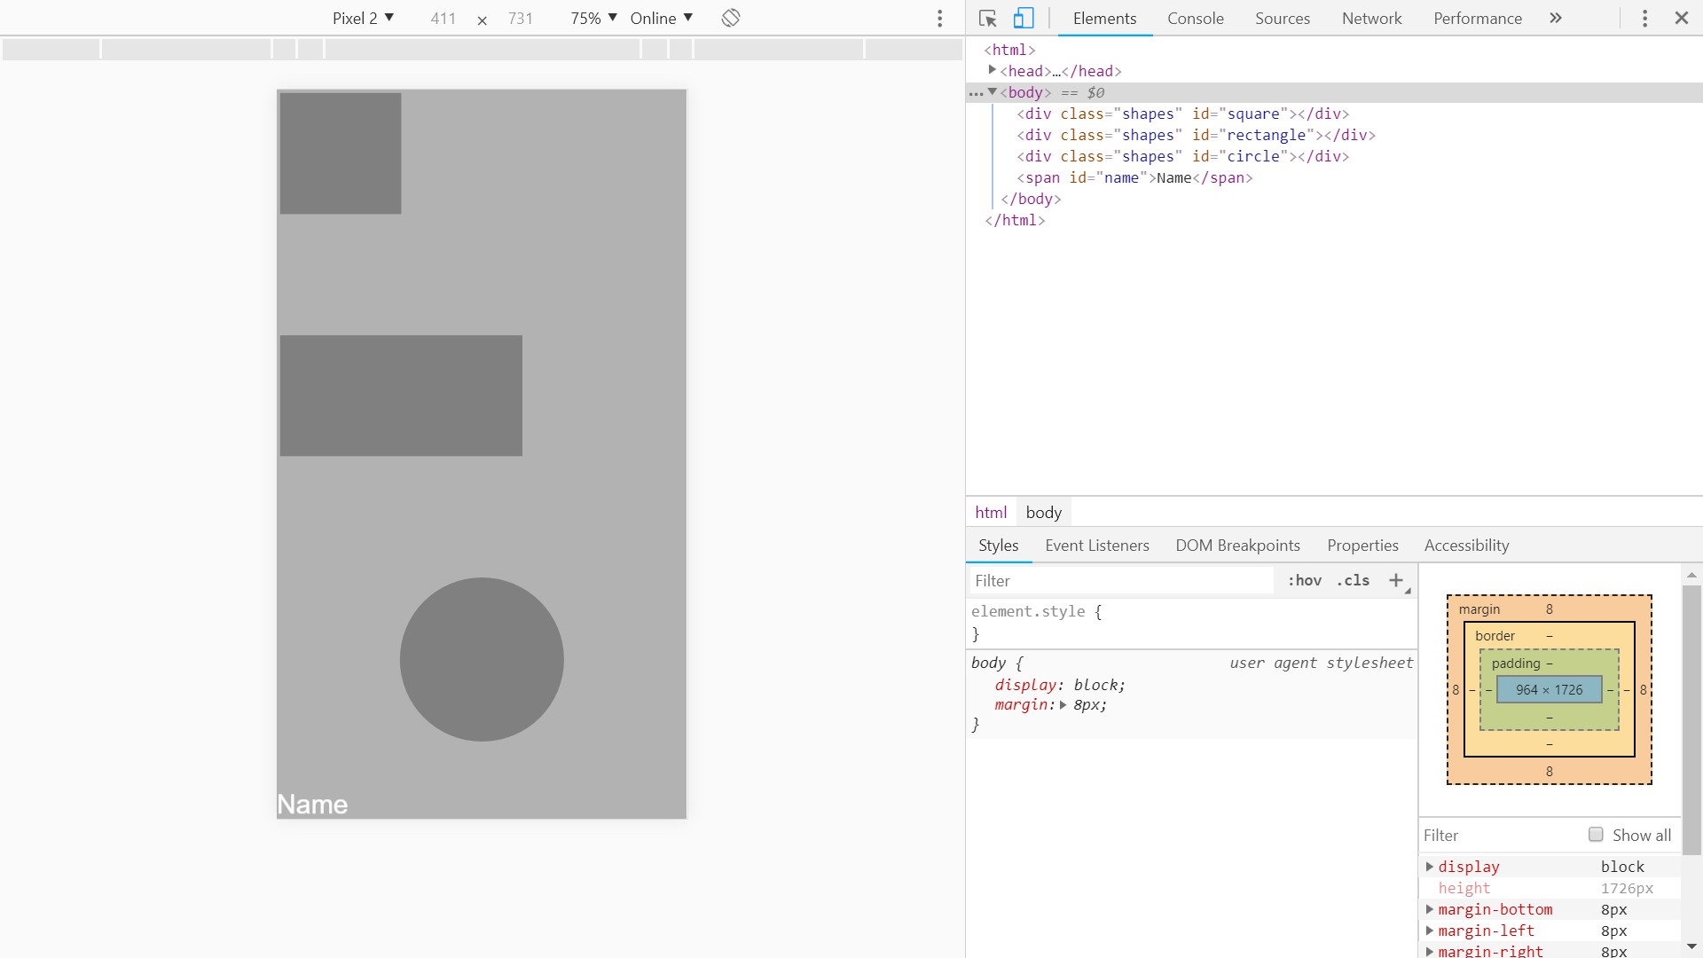

Page Response

1. Rotate the device emulator to the landscape orientation. Upon rotation, the following should change.
2. Change the square to half the size it is in portrait orientation.
3. Remove the rectangle.
4. Put the circle in the top right-hand corner.
5. Ensure your name still stays in place in the bottom left hand corner when you scroll.

Your page should look like this:

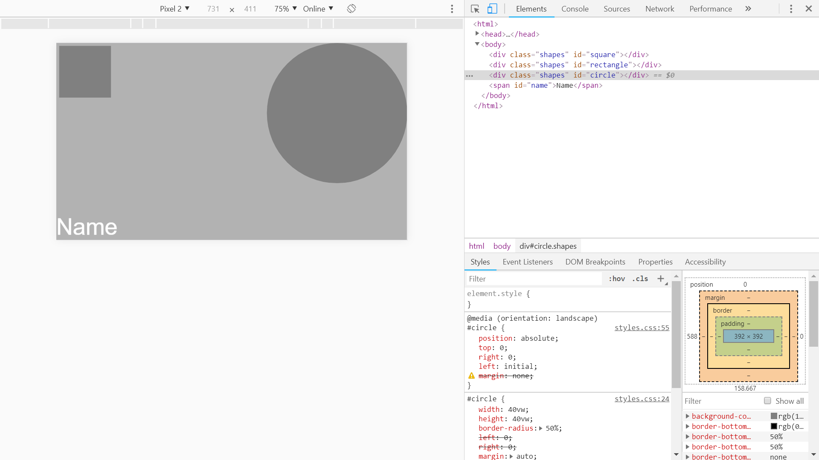

Conditional name colour

1. Write some code to change the colour of your name every 5 seconds through an array of colours.
2. Do this only if your page is scrolled down and not at the top.